User Guide — The Summarizer

The Summarizer — User Guide

Overview
The Summarizer extracts key insights from your documents and produces a concise executive summary with key points. It supports multiple files at once and includes a built-in Vietnamese translation feature.
──────────────────────────────────────────────────

Supported File Types
- PDF (.pdf)
- Word (.docx)
- PowerPoint (.pptx)
- Plain Text (.txt)
Maximum file size: 20 MB per file
──────────────────────────────────────────────────

Interface Layout
The page is divided into 3 panels:
Panel | Purpose
Left (Upload) | Upload files and trigger summarization
Middle (Extracted Content) | Shows the raw parsed text from your documents
Right (Executive Summary) | Displays the AI-generated summary and key insights
──────────────────────────────────────────────────

How to Use
When get to summerize page, the default UI will be

Step 1: Upload Documents
In the top panel, drag and drop one or more files into the dropzone, or click to browse. You can upload multiple files — each appears as a chip with a remove (×) button.
> ⚠️ PII Notice: Do not upload documents containing sensitive personal information.

Step 2: Start Summarization
Click "Summarize N file(s)" below. The button shows the count of selected files.

Step 3: Monitor Progress
Both the middle and right panels show progress indicators:
- Upload — Files are being sent to the server
- Parse — Text is being extracted from documents
- Summarize — AI is analyzing and generating the summary (30–90 seconds)
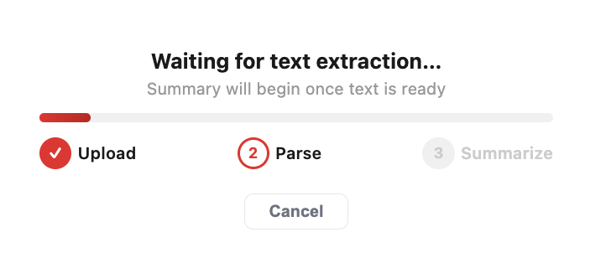
A progress bar and step indicators show the current phase.

Step 4: Review Results
Once complete, there are 3 panels with different information:
- Summarize: show comprehensive overview from document context

- Key Insights — Numbered bullet points highlighting the most important findings
- Mind Map - Represent knowledge in uploaded document as knowledge tree

Step 5: Additional Actions
- Allows display results with both English and Vietnamese
- Store and display the processing history status of documents. This includes the status (Done/Fail) and the detailed summary content, which can be viewed by clicking on the corresponding document.
──────────────────────────────────────────────────

Tips
- Upload multiple related documents together for a combined summary
- For very large documents, the system uses an advanced multi-pass summarization strategy — a blue info banner will indicate this
- The character count in the middle panel helps you understand how much content was analyzed
- Key Insights are numbered and can be used directly in reports or presentations
──────────────────────────────────────────────────

Limitations
- Maximum file size: 20 MB per file
- Very long documents may be truncated due to context window limits
- Summarization typically takes 30–90 seconds depending on document length
- Translation feature translates the summary only, not the full extracted text
──────────────────────────────────────────────────
Last updated: 2026-07-15

